Bypassing the Windows 7 machine password by using ophcrack tool and change the password from command prompt without knowing old password.

-windows 7 account victim

- we want to bypass the login

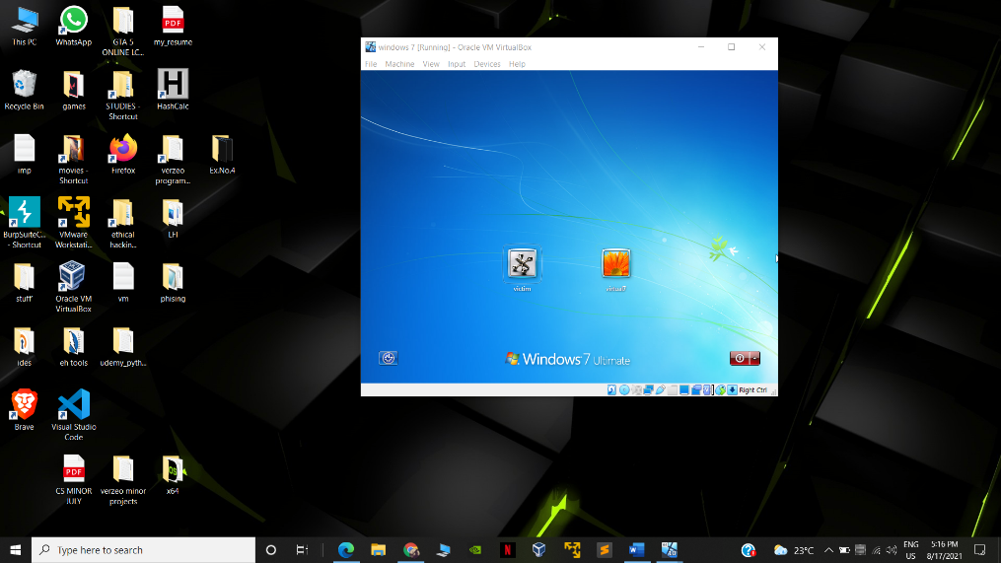

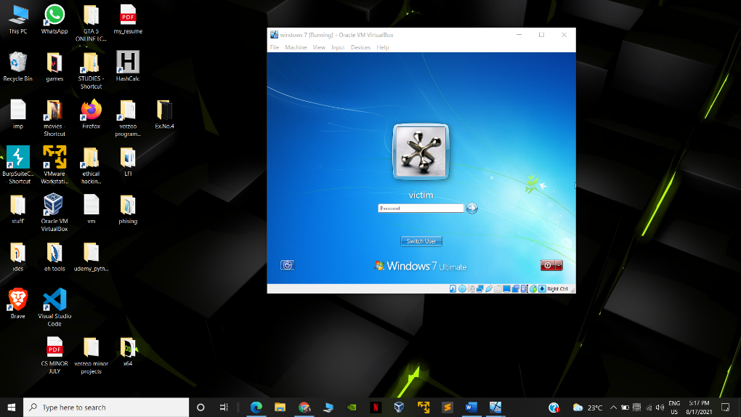

-Download ophcrack iso file and add it to storage in optical drive.

-start the machine it will boot with ophcrach automatically

-it will automatically crack the password !!!

manual :

-in os click on ophcrack->load encrypted session file

-location -> media/sda2/windows/system32/connfig

-select any available rainbow table then click crack !

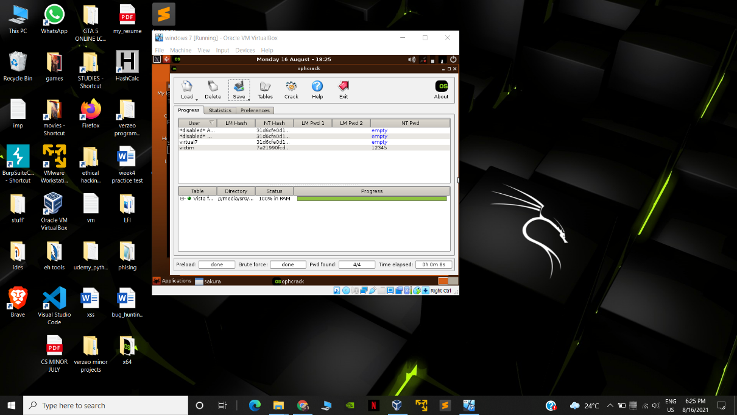

NOW FOR CHANING THE PASSWORD VIA CMD WITHOUT USING PREVIOUS PASSWORD

-type cmd

-run as admin

-net users

-net user <username> <password>

Eg . net user victim pass

PASSWORD GETS CHANGED !!

